Lesson 2

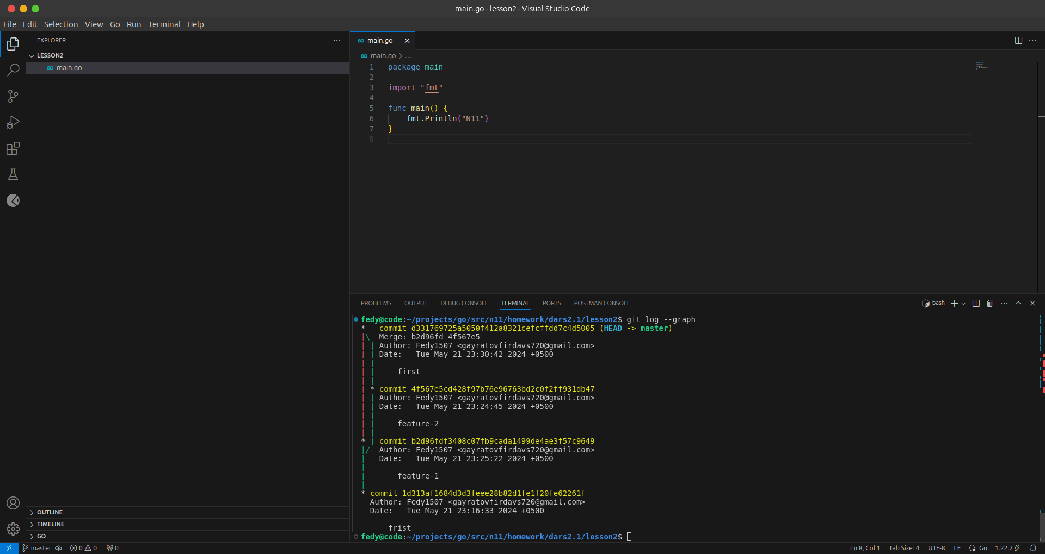git add .

git commit -m "frist"

git branch feature-1

git branch feature-2

git branch

git checkout feature-1

git checkout feature-2

git branch

git add .

git commit -m "feature-2"

git checkout feature-1

git add .

git commit -m "feature-1"

git checkout master

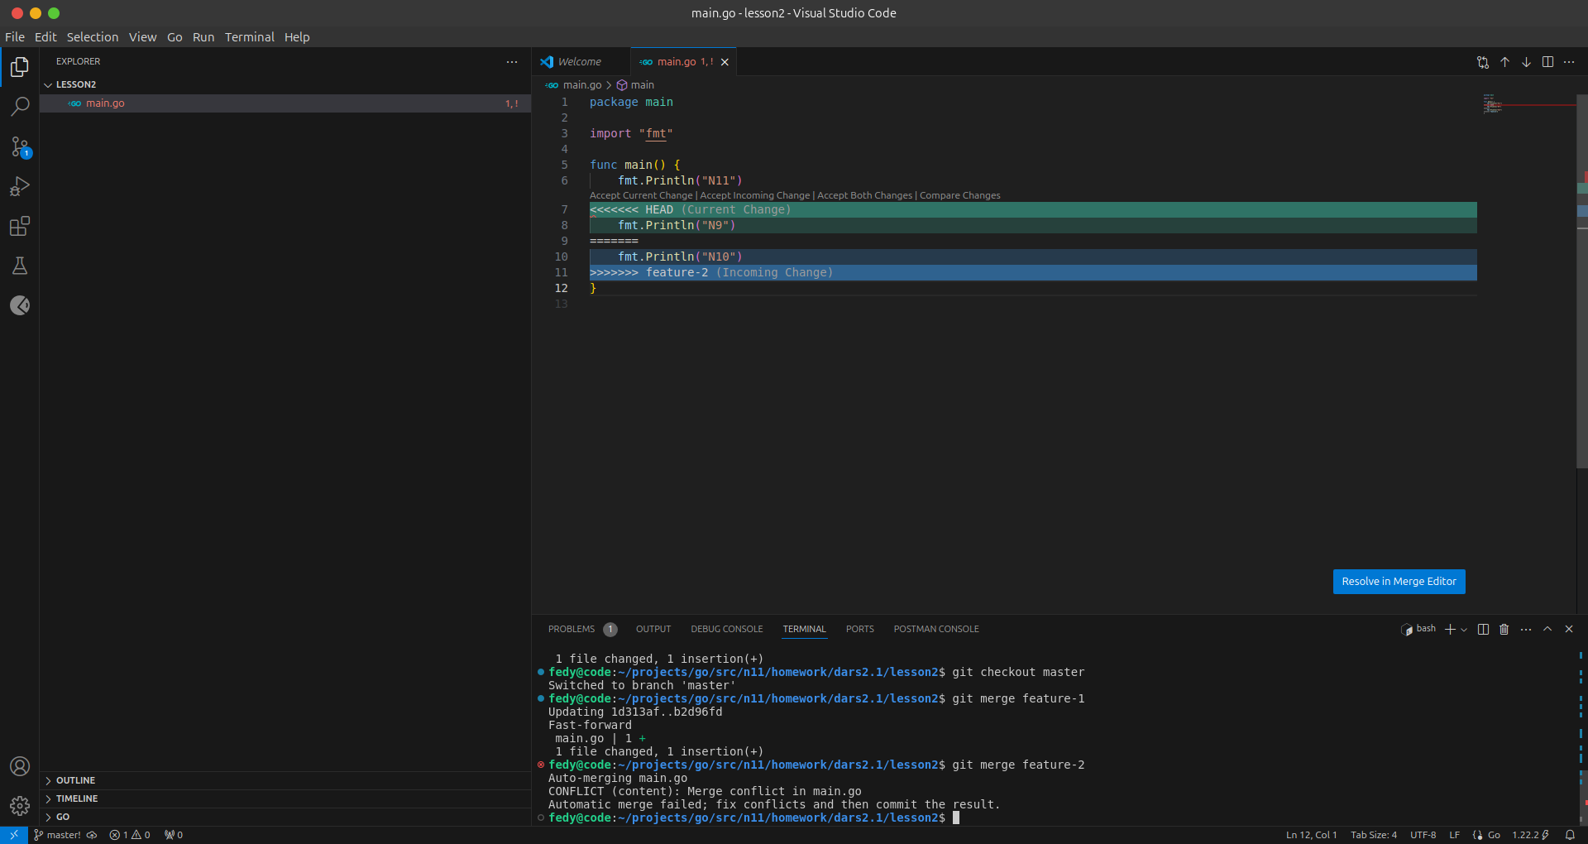git merge feature-1

git merge feature-2

git branch -d feature-1

git branch -d feature-2

git branch

git log --graph

history